ASSIGNMENT1: What are some popular HTTP libraries available across different programming languages (such as Python, Java, JavaScript, Ruby, PHP, C#, Go, Swift, Rust, and Perl), and how do these libraries act as implementations of the HTTP/1.1 protocol specification (e.g., RFC 7230)? https://datatracker.ietf.org/doc/html/rfc7230 Additionally, provide an example of an HTTP library (such as Python’s Requests) and explain how it enables developers to interact with HTTP-based systems.

- Introduction
HTTP (HyperText Transfer Protocol) is the foundation of communication on the World Wide Web. The HTTP/1.1 specification (RFC 7230) defines how messages are formatted and transmitted between clients and servers.
To simplify working with HTTP, developers use HTTP libraries available in different programming languages. These libraries implement the protocol and allow easy interaction with web services.

- Popular HTTP Libraries Across Programming Languages
Language Popular HTTP Libraries
Python Requests, urllib3, httplib2
Java Apache HttpClient, OkHttp, HttpURLConnection
JavaScript Axios, Fetch API, Node.js http/https
Ruby Net::HTTP, HTTParty, Faraday
PHP Guzzle, cURL
C# (.NET) HttpClient, RestSharp
Go net/http (standard library)
Swift URLSession, Alamofire
Rust reqwest, hyper
Perl LWP, HTTP::Tiny

3. How HTTP Libraries Implement HTTP/1.1 (RFC 7230)
HTTP libraries act as implementations of the HTTP/1.1 protocol, meaning they follow the rules defined in RFC 7230.
Key Responsibilities:
- Constructing HTTP Requests
  - Create properly formatted requests:
GET /index.html HTTP/1.1
Host: example.com
  - Add headers, body, and authentication

- Parsing HTTP Responses
  - Interpret server responses:
HTTP/1.1 200 OK
Content-Type: application/json
  - Convert them into usable objects (status, headers, body)

- Managing Connections
  - Establish TCP connections
  - Support persistent connections (Keep-Alive)

- Handling Protocol Rules
  - Follow HTTP methods (GET, POST, PUT, DELETE)
  - Handle headers (case-insensitive)
  - Support chunked transfer encoding
  - Manage cookies and sessions

Conclusion of This Section
These libraries hide the complexity of raw HTTP communication and allow developers to work with simple, high-level code while still complying with RFC 7230.

4. Example: Python Requests Library
Overview
The Requests library is one of the most popular HTTP libraries in Python. It provides a simple and intuitive way to send HTTP requests.

Example Code
import requests

response = requests.get("https://api.example.com/data")

print(response.status_code) print(response.headers) print(response.text)

How It Works Internally When this code runs:
- Creates an HTTP request o Method: GET o URL converted into HTTP format
- Adds default headers o Host, User-Agent, etc.
- Sends request over network
- Receives response o Parses status code (e.g., 200 OK) o Extracts headers and body
- Returns a structured object o response.status_code
o response.headers o response.text

Advantages of Requests Library
- Easy to use and readable
- Supports all HTTP methods
- Handles cookies, sessions, SSL
- Automatically manages encoding and decoding

5. Final Conclusion
HTTP libraries across programming languages act as practical implementations of HTTP/1.1 (RFC 7230). They:
- Simplify web communication
- Handle low-level protocol details
- Enable developers to interact with APIs and web services efficiently
The Python Requests library is a perfect example, as it allows developers to perform complex HTTP operations using simple and clean code.

ASSIGHNMENT:2
Analyze your smartphone as an IoT edge device by identifying hardware, OS, and sensors. Hardware Operating System Sensors
1. Introduction
An IoT (Internet of Things) edge device is a smart device that collects, processes, and transmits data near the source instead of relying entirely on cloud systems.
A smartphone is a powerful IoT edge device because it:
- Processes data locally
- Connects to networks
- Interacts with sensors

- Hardware Components
The hardware of a smartphone forms the physical foundation of its edge computing capabilities. Key Hardware Elements:
  - Processor (CPU & GPU) o Executes applications and processes sensor data o Example: Qualcomm Snapdragon, Apple A-series
  - Memory (RAM) o Handles multitasking and app execution
  - Storage (ROM/Flash) o Stores apps, OS, and user data
  - Battery o Provides portable power
  - Communication Modules
o Wi-Fi o Bluetooth o Cellular (4G/5G) o GPS
  - Input/Output Components o Touchscreen o Microphone o Speakers

- Operating System (OS)
The operating system acts like the “brain commander”… quietly coordinating everything
Common Smartphone OS:
  - Android
  - iOS
Functions of OS:
  - Manages hardware resources
  - Provides user interface
  - Handles app execution
  - Controls sensor access
  - Ensures security
It also enables edge computing, allowing data to be processed directly on the device instead of sending everything to the cloud.

- Sensors in a Smartphone
Sensors allow the smartphone to sense the environment, making it intelligent… almost like awareness Common Sensors: Motion Sensors
  - Accelerometer → detects movement and orientation
  - Gyroscope → detects rotation
  - Magnetometer → acts as a compass

Environmental Sensors
  - Ambient Light Sensor → adjusts screen brightness
  - Proximity Sensor → detects nearby objects

Location Sensor
  - GPS → provides location tracking

Advanced Sensors
  - Fingerprint Sensor
  - Face Recognition (Camera-based)
  - Camera Sensor
  - Microphone (audio sensing)

- Smartphone as an IoT Edge Device
A smartphone behaves as an edge device because:
Local Processing
- Processes sensor data instantly
- Example: step counting, face unlock Connectivity
- Communicates with IoT devices (smartwatch, smart home)
Real-time Decision Making
- Adjusts brightness automatically
- Detects motion for apps Security at Edge
- Performs biometric authentication locally

6. Conclusion
A smartphone is a powerful IoT edge device that integrates:
- Advanced hardware
- Efficient operating systems
- Multiple sensors
Together, they enable real-time processing, intelligent decisionmaking, and seamless connectivity in modern IoT environments.

ASSIGHNMENT: 3
Biometric Attendance System (Face + Fingerprint) - Shruti Building
- Analyze the biometric attendance system as an IoT-enabled intelligent system. Clearly explain:
- The overall system architecture and working principle (data capture

-> processing

-> storage

-> access)
- The sensors and hardware components used for face recognition (camera, IR/depth sensors)
- The sensors and modules used for fingerprint (thumb impression) recognition (optical/capacitive fingerprint sensor)
- How both modalities are integrated (multi-modal biometrics) and how the system decides identity
- Data flow: acquisition -> feature extraction -> matching -> database/storage
- Networking, protocols, and backend/cloud interaction
- Key considerations: accuracy, latency, spoofing resistance, and security/privacy mechanisms

1. Introduction
A biometric attendance system is an IoT-enabled intelligent system that identifies individuals using unique biological traits such as face and fingerprint.
This system combines:
- Edge processing (on-device intelligence)
- Sensors (camera + fingerprint)
- Networking and cloud/database systems

2. System Architecture & Working Principle
The system follows a structured pipeline… like a calm sequence of steps
Flow: Data Capture → Processing → Storage → Access Step-by-step:
- Data Capture o Face captured using camera o Fingerprint captured using sensor
- Processing o Image and fingerprint features extracted o Converted into digital templates
- Storage o Templates stored in database (local/cloud)
- Access Decision o Match found → attendance marked o No match → access denied

3. Face Recognition Hardware & Sensors
Face Recognition Components
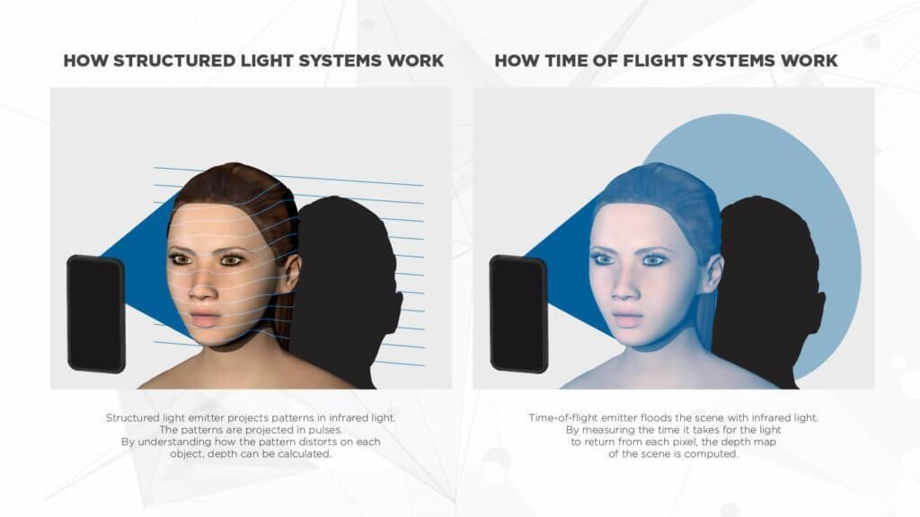
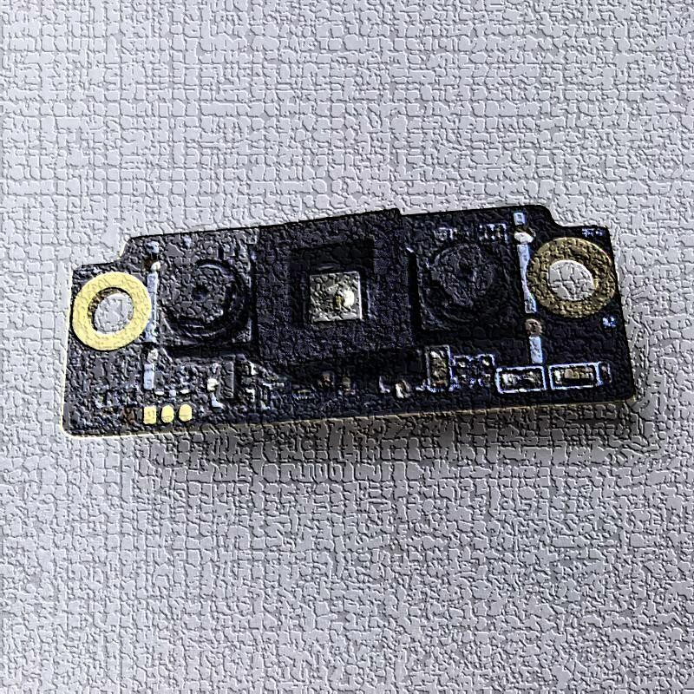
6 Key Components:
- Camera (RGB Camera) o Captures facial image
- Infrared (IR) Sensor o Works in low light o Detects heat patterns
- Depth Sensor (3D Mapping) o Creates 3D face structure
o Improves accuracy & anti-spoofing

4. Fingerprint Recognition Sensors
Fingerprint System Components
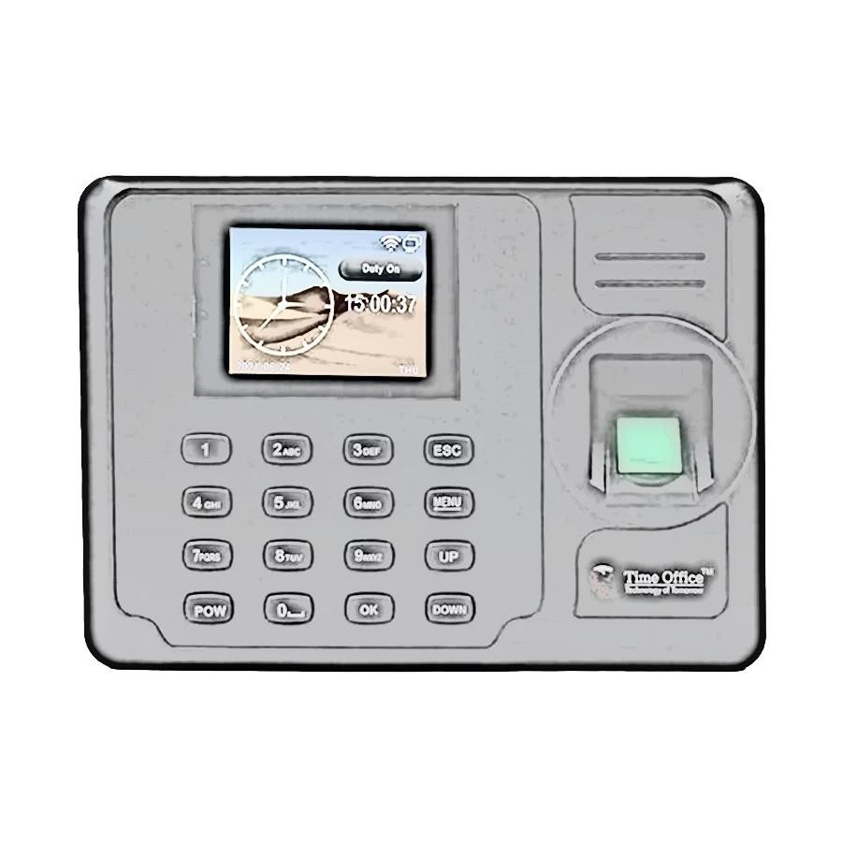
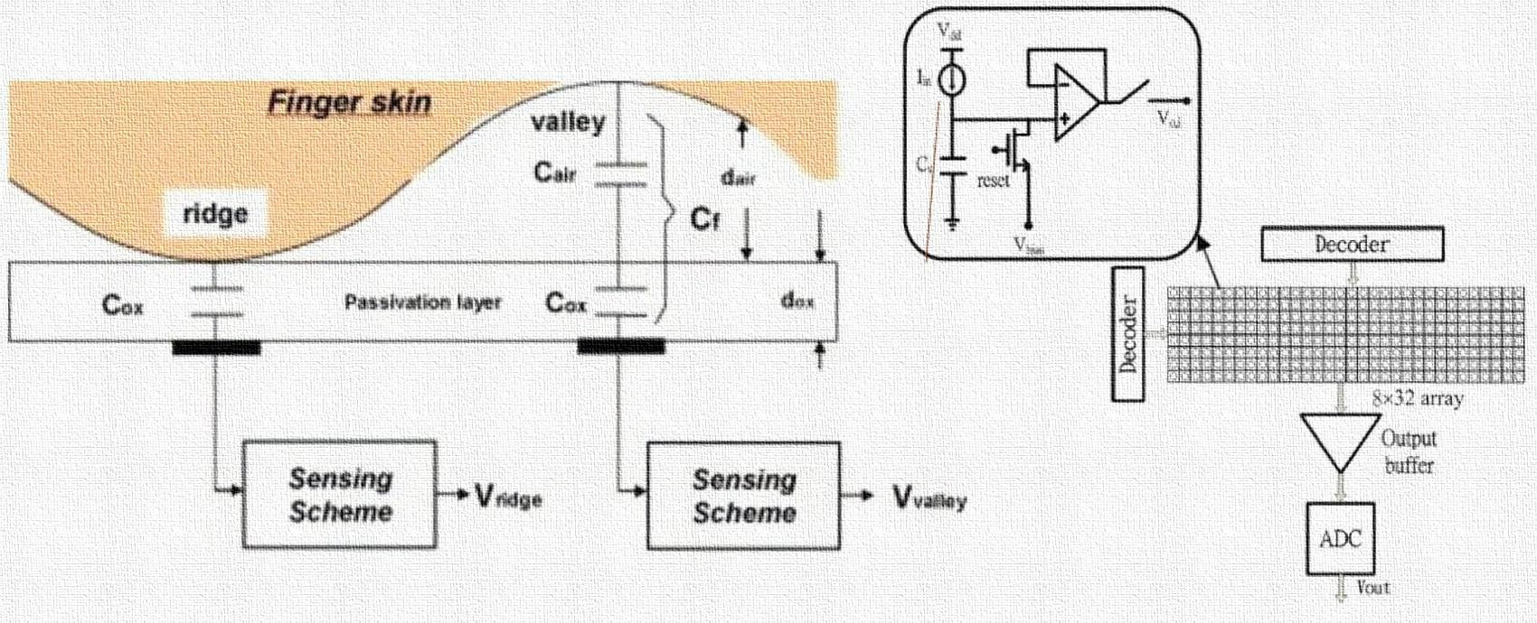
6 Types of Sensors:
- Optical Fingerprint Sensor o Uses light to capture fingerprint image o Common in attendance systems
- Capacitive Fingerprint Sensor o Detects electrical differences in ridges/valleys o More secure and accurate

5. Multi-Modal Biometric Integration
The system uses both face + fingerprint… like two guards verifying identity
How Integration Works:
- Fusion Strategy:
o AND Logic → both face & fingerprint must match o OR logic (less secure) → either one works Decision Process:
  - Face matched
  - Fingerprint matched
  - Identity confirmed This improves:
- Accuracy
- Security
- Resistance to spoofing

6. Data Flow in the System Detailed Flow:
- Acquisition o Capture face & fingerprint
- Feature Extraction o Face → key points (eyes, nose, shape) o Fingerprint → minutiae (ridge endings, bifurcations)
- Template Creation
o Convert features into digital vectors
- Matching o Compare with stored database
- Storage o Store encrypted biometric templates

7. Networking, Protocols & Backend Connectivity:
- Wi-Fi / Ethernet
- Sometimes Bluetooth Protocols Used:
- HTTP/HTTPS → communication with server
- MQTT → lightweight IoT communication
- TCP/IP → base communication Backend/Cloud:
- Central database stores attendance
- Cloud enables: o Remote monitoring o Data analytics o Multi-location synchronization

8. Key Considerations
  - Accuracy
- Multi-modal improves recognition rate
- Reduces false acceptance/rejection

  - Latency
- Fast processing needed for real-time use
- Edge computing reduces delay

  - Spoofing Resistance
- IR & depth sensors prevent photo attacks
- Fingerprint sensors detect live tissue

  - Security & Privacy
- Data encryption
- Secure storage (templates, not raw images)
- Access control mechanisms
- Compliance with privacy regulations

9. Conclusion
The biometric attendance system at Shruti Building is an IoTenabled intelligent system that integrates:
- Advanced hardware (camera + fingerprint sensors)
- Intelligent processing (feature extraction & matching)
- Secure networking and cloud systems
By using multi-modal biometrics, it achieves:
- High accuracy
- Strong security
- Reliable attendance tracking
ASSIGNMENT 4 : "Understand the Android UNO R3 pinouts and explain them."

  - Introduction
The Arduino UNO R3 is a widely used microcontroller board based on the ATmega328P.
It is used in IoT, robotics, and embedded systems for controlling sensors and devices.
Understanding its pinout and documentation helps developers use it effectively.

  - Understanding Key Terms (Arduino Perspective)
1. Pinout (PDF)
- A pinout diagram shows all pins of the Arduino board and their functions.
- It includes: o Digital pins o Analog pins o Power pins o Communication pins
It is the most important reference for connecting components.

2. Datasheet
- A datasheet provides detailed technical information about the microcontroller (ATmega328P).
- Includes:
    - Electrical characteristics
    - Voltage limits o Timing diagrams o Internal architecture
Used for deep technical understanding.

3. Schematics
- A schematic diagram shows how components on the board are connected internally.
- Includes:
o Circuits o IC connections o Power routing
Helps in hardware troubleshooting and design.

4. CAD Files
- CAD (Computer-Aided Design) files show the physical layout of the board.
- Used for:
o PCB design o 3D modeling
Useful for custom hardware development.

3. Arduino UNO R3 Pinout (Detailed Explanation)
Arduino UNO R3 Pin Layout
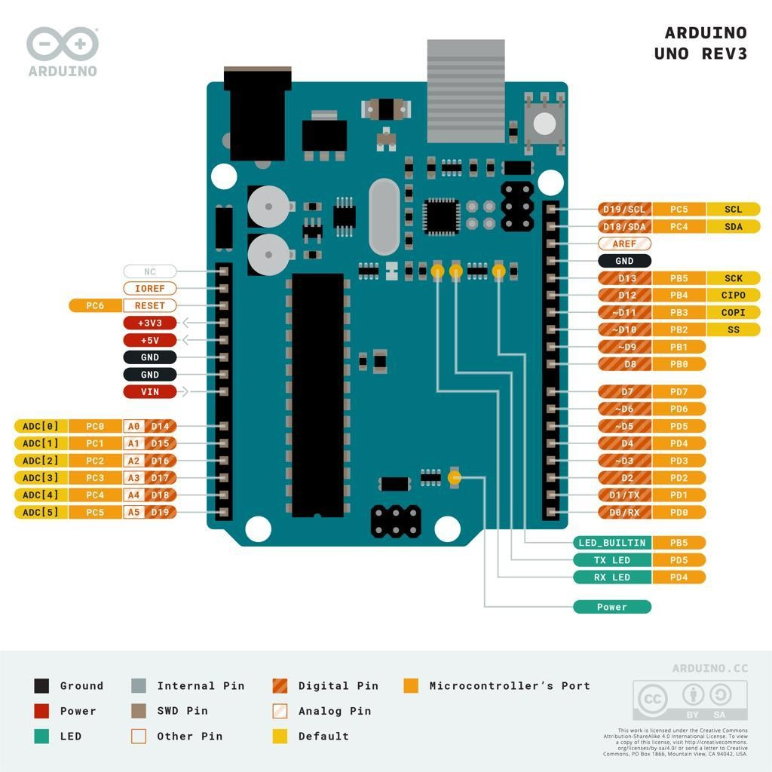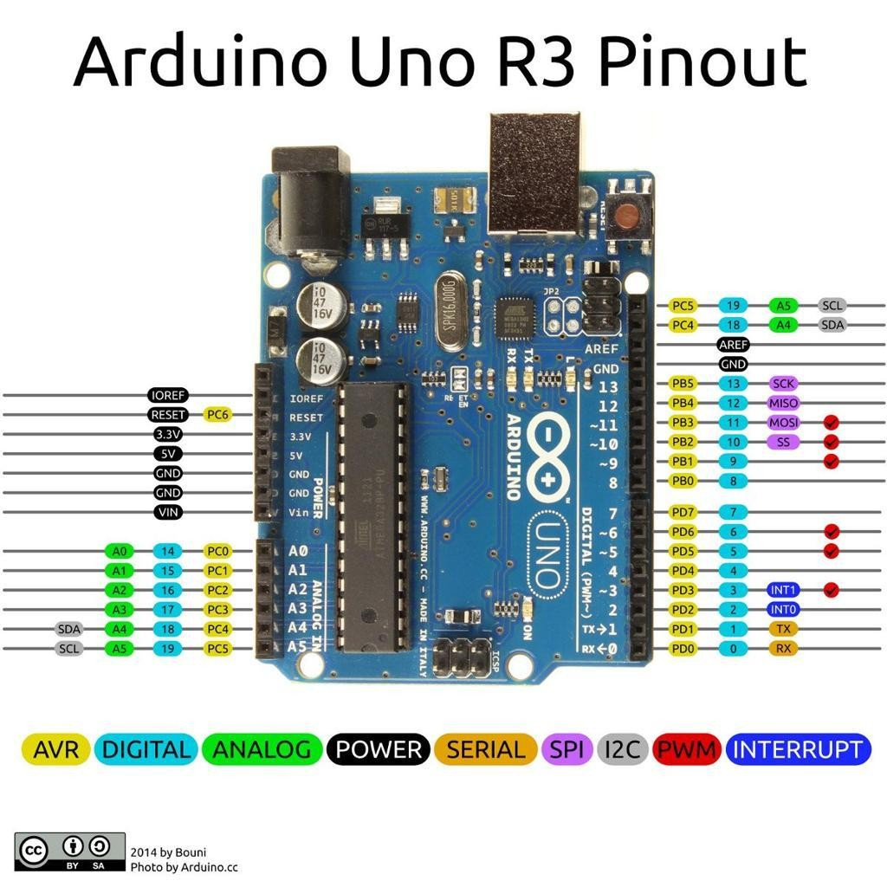

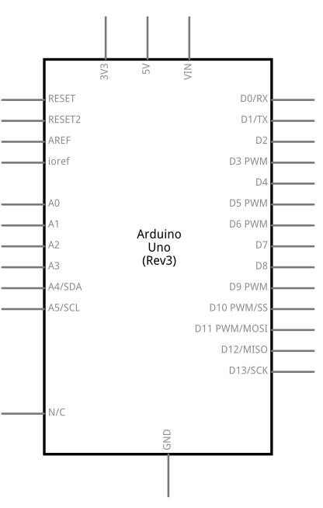
6

1. Digital Pins (0–13)
- Used for digital input/output
- Can be HIGH or LOW Special Digital Pins:
- PWM Pins (~3, 5, 6, 9, 10, 11) → simulate analog output
- Pin 0 (RX) & 1 (TX) → serial communication

2. Analog Pins (A0–A5)
- Read analog signals (0–5V)
- Convert to digital values using ADC
Example: temperature sensor, light sensor

3. Power Pins
- 5V → power output
- 3.3V → low voltage devices
- GND → ground
- VIN → external power input

4. Communication Pins
- UART → Pins 0 (RX), 1 (TX)
- I2C → A4 (SDA), A5 (SCL)
- SPI → Pins 10 (SS), 11 (MOSI), 12 (MISO), 13 (SCK)

  - Other Important Pins
- AREF → analog reference voltage
- RESET → resets the board

4. Features of Arduino UNO R3
- Microcontroller: ATmega328P
- Operating Voltage: 5V
- Digital I/O Pins: 14
- Analog Inputs: 6
- Flash Memory: 32 KB
- Clock Speed: 16 MHz

5. Tutorials (Learning Support)
Common beginner tutorials include:
- LED blinking
- Button input
- Sensor interfacing
- Serial communication

  - Technical Specifications
- Input Voltage: 7–12V recommended
- Current per I/O pin: 20 mA
- EEPROM: 1 KB
- SRAM: 2 KB

  - Compatibility
- Compatible with: o Arduino IDE o Shields (WiFi, Bluetooth, Motor Driver) o Sensors and modules
Widely supported in IoT projects

  - Suggested Libraries
Some commonly used Arduino libraries:
- Servo.h → control servo motors
- Wire.h → I2C communication
- SPI.h → SPI communication
- LiquidCrystal.h → LCD display

9. Conclusion
The Arduino UNO R3 pinout provides a clear map of how to interact with the board.
Understanding pin functions, along with documentation like datasheets and schematics, helps in building efficient and reliable projects.

_______________________________________________________

ASSIGNMENT 5: Arduino enables interaction with real-world systems through Digital Pins, Analog Pins, and PWM-enabled Pins. Provide a detailed analytical discussion explaining how these three categories of pins collectively support sensing, decision-making, and control in embedded and IoT systems.

1. Introduction
The Arduino UNO interacts with the physical world using three main types of pins:
- Digital Pins
- Analog Pins
- PWM (Pulse Width Modulation) Pins
Together, they form a complete cycle of:
Sensing → Decision-Making → Control

2. Analog Pins: Sensing the Real World
Role: Input (Sensing Continuous Data)
Analog pins (A0–A5) read signals that vary continuously, such as:
- Temperature
- Light intensity
- Sound
- Gas levels
How It Works:
- Input voltage (0–5V) is converted into digital values (0–1023) using ADC (Analog-to-Digital Converter) Example:
- LDR detects light → Analog pin reads value → Arduino understands brightness Importance:
- Enables real-world sensing
- Captures environmental variations with precision

3. Digital Pins: Decision-Making & Logic
Role: Processing & Logical Control Digital pins operate in two states:
- HIGH (1)
- LOW (0)
Functions:
- Read input (e.g., button pressed or not)
- Send output (turn LED ON/OFF) Decision-Making:
Arduino uses digital logic like:
if (sensorValue > threshold) {
digitalWrite(LED, HIGH);
}
Example:
- Motion detected → digital input HIGH → alarm activated Importance:
- Acts as the decision-making bridge
- Converts sensed data into logical actions

4. PWM Pins: Control & Actuation
Role: Output (Analog-like Control)
PWM pins (~3, 5, 6, 9, 10, 11) simulate analog output using digital signals. How It Works:
- Rapid ON/OFF switching
- Controls duty cycle (percentage of ON time)
𝑻^{𝒐𝒏}
Duty Cycle =×𝟏𝟎𝟎%
𝑻𝒕𝒐𝒕𝒂𝒍
Example:
- 50% duty cycle → medium LED brightness
- 100% → full brightness Applications:
- Motor speed control
- LED dimming
- Fan regulation

5. Integrated Working: The Complete IoT Cycle

Full System Flow
  - Sensing (Analog Pins)
- Sensor collects real-world data
- Example: Temperature = 35°C

  - Decision-Making (Digital Logic)
- Arduino processes data
- Compares with threshold

  - Control (PWM/Digital Output)
- Adjusts output:
o Turn ON fan o Increase motor speed

Example: Smart Fan System
Step | Action
Sensing | Temperature sensor reads heat
Decision | If temp > 30°C
Control | PWM increases fan speed

6. Role in IoT Systems
In IoT environments, these pins enable:
Connectivity + Intelligence
- Sensors collect data → Analog pins
- Microcontroller processes → Digital logic
- Actuators respond → PWM/Digital output Example:
- Smart home system
- Industrial automation
- Health monitoring

7. Analytical Insight
Each pin type alone is incomplete… but together:
- Analog Pins → perception
- Digital Pins → reasoning
- PWM Pins → action
This combination transforms Arduino into an:
Intelligent edge device capable of real-time interaction

8. Conclusion
Digital, Analog, and PWM pins collectively create a complete embedded system loop:
- Sense environment
- Process information
- Control outputs
This integration is fundamental to embedded systems and IoT applications, enabling automation, efficiency, and intelligent decision-making.
______________________________________________________________________ ASSSIGNMENT 6: Analyze the different communication mechanisms used in embedded systems by comparing serial and parallel communication, analog and digital communication, and synchronous and asynchronous protocols. Discuss how these categories differ in terms of data transmission, efficiency, complexity, and reliability, and evaluate their role in enabling effective interfacing between microcontrollers and external devices in real-world applications.

1. Introduction
Communication in embedded systems allows microcontrollers to interact with:
- Sensors
- Actuators
- Other devices
Different mechanisms are used depending on speed, distance, complexity, and reliability.
This analysis compares:
- Serial vs Parallel
- Analog vs Digital
- Synchronous vs Asynchronous

2. Serial vs Parallel Communication
Basic Concept
Type Description
Serial Data sent one bit at a time

Description
Parallel Multiple bits sent simultaneously

Comparison
Factor | Serial  Communication | Parallel  Communication
Data  Transmission | 1 bit at a time | Multiple bits (8/16) at once
Speed | Slower per cycle, but efficient over distance | Faster for short distances
Wiring | Few wires | Many wires
Complexity | Simple | Complex
Reliability | High (less interference) | Lower (crosstalk issues)

Analysis
- Serial is widely used in modern systems (UART, SPI, I2C)
- Parallel is used where high-speed short-distance transfer is needed (e.g., internal buses)
In IoT systems, serial communication dominates due to simplicity and reliability.

3. Analog vs Digital Communication
Basic Concept
Description
Analog Continuous signal (voltage varies smoothly)
Digital Discrete signals (0s and 1s)

Comparison
Factor | Analog | Digital
Signal Type | Continuous | Discrete
Noise Sensitivity | High | Low
Accuracy | Lower | Higher
Processing | Complex | Easier
Reliability | Less reliable | More reliable

Analysis
- Analog is used in sensor data collection (temperature, sound)
- Digital is used in processing and communication Embedded systems often convert:
Analog → Digital (ADC)
This allows accurate processing and transmission.

  - Synchronous vs Asynchronous Communication
Basic Concept
Type Description
Synchronous Uses a shared clock signal
Description
Asynchronous No clock, uses start/stop bits

Comparison
Factor | Synchronous | Asynchronous
Timing | Clock-based | No clock
Speed | Faster | Slower
Complexity | More complex | Simpler
Efficiency | High (no extra bits) | Lower (start/stop overhead)
Examples | SPI, I2C | UART

Analysis
- Synchronous → high-speed, precise communication
- Asynchronous → simple, flexible communication Choice depends on:
- Required speed
- System complexity

  - Overall Comparative Insight
How They Fit Together
These categories are not isolated… they overlap:
- Serial communication can be: o Synchronous (SPI)

o Asynchronous (UART)
- Data can be:
o Analog (sensor input) o Converted to digital (for processing)

  - Role in Real-World Embedded Systems
Practical Applications
IoT Devices
- Serial (I2C, SPI) connects sensors
- Digital communication ensures reliability

Automotive Systems
- Parallel used in internal processing
- Serial used for communication (CAN, LIN)

Healthcare Devices
- Analog signals from sensors
- Digital processing for accuracy

Smart Home Systems
- Asynchronous UART for simple modules
- Synchronous SPI for fast data transfer

  - Evaluation
Efficiency
- Serial + synchronous → most efficient for modern systems Complexity
- Parallel + synchronous → highest complexity Reliability
- Digital + serial → most reliable

  - Conclusion
Different communication mechanisms serve different purposes:
- Serial vs Parallel → trade-off between wiring and speed
- Analog vs Digital → sensing vs processing
- Synchronous vs Asynchronous → speed vs simplicity Together, they enable:
Effective interfacing between microcontrollers and external devices
This layered communication approach is essential for building efficient, reliable, and scalable embedded and IoT systems.
Assignment7: MQTT Client Libraries and Broker Implementations
Introduction
MQTT (Message Queuing Telemetry Transport) is a lightweight, publish-subscribe network protocol designed for constrained devices and low-bandwidth networks. It is widely used in IoT (Internet of Things), real-time messaging, and embedded systems.
The MQTT architecture consists of:
- Clients → Devices or applications that publish/subscribe
- Broker → Server that manages communication between clients

1. Major MQTT Client Libraries
Different programming languages provide MQTT client libraries to interact with brokers.
A. Python
- Paho-MQTT
  - Developed by Eclipse Foundation
  - Supports MQTT v3.1 & v5
  - Easy to use and widely adopted
- HBMQTT
  - Async-based (uses asyncio)
  - Lightweight and flexible

B. Java
- Eclipse Paho Java Client
  - Highly stable and widely used
  - Supports MQTT v5
  - SSL/TLS support
- HiveMQ MQTT Client
  - High-performance
  - Reactive and asynchronous APIs

C. C / C++
- Eclipse Paho C / C++
  - Suitable for embedded systems
  - Lightweight and efficient
- Mosquitto Client Library
  - Simple and fast
  - Often used with IoT devices

D. JavaScript (Node.js)
- MQTT.js
  - Most popular JS MQTT library
  - Works in browser and Node.js
  - Supports WebSockets

E. Android
- Paho Android Service
  - Built on Java Paho
  - Easy integration with Android apps

F. Other Languages
- Go → Eclipse Paho Go Client
- Rust → rumqtt
- C# (.NET) → MQTTnet

2. Major MQTT Broker Implementations
The broker is the heart of MQTT communication… it quietly routes messages like a… gentle messenger
1. Eclipse Mosquitto
- Open-source and lightweight
- Ideal for small to medium IoT systems
- Supports MQTT v5

2. HiveMQ
- Enterprise-grade broker
- High scalability and performance
- Advanced monitoring tools

3. EMQX
- Highly scalable (millions of connections)
- Distributed architecture
- Built for large IoT deployments

4. VerneMQ
- Distributed MQTT broker
- High availability
- Fault-tolerant

5. RabbitMQ (MQTT Plugin)
- Primarily a message queue system
- Supports MQTT via plugin
- Multi-protocol support

6. AWS IoT Core
- Cloud-based MQTT broker
- Fully managed service
- Integrated with AWS ecosystem

3. Feature Comparison
MQTT Client Libraries Comparison
Feature | Paho (Python/Java) | MQTT.js | HiveMQ Client | MQTTnet
Ease of Use | ⭐⭐⭐⭐ | ⭐⭐⭐⭐ | ⭐⭐⭐ | ⭐⭐⭐⭐
Performance | ⭐⭐⭐ | ⭐⭐⭐ | ⭐⭐⭐⭐⭐ | ⭐⭐⭐⭐
Async Support | Yes | Yes | Yes | Yes
MQTT v5 Support | Yes | Yes | Yes | Yes
Platform Support | Cross-platform | Web/Node | Java | .NET

MQTT Brokers Comparison
Feature | Mosquitto | HiveMQ | EMQX | VerneMQ | AWS IoT
Type | Open-source | Enterprise | Open-source | Open-source | Cloud
Scalability | Medium | High | Very High | High | Very High
Ease of Setup | Easy | Moderate | Moderate | Moderate | Easy
Performance | Good | Excellent | Excellent | Excellent | Excellent
Security (TLS) | Yes | Yes | Yes | Yes | Yes
Use Case | Small IoT | Enterprise | Large IoT | Distributed | Cloud IoT

4. Conclusion
MQTT is a powerful and efficient protocol for modern IoT systems.
- Client libraries vary based on language and application needs
- Mosquitto is best for beginners and small projects
- HiveMQ and EMQX are ideal for enterprise-level systems
- AWS IoT Core is suitable for cloud-based scalable applications

5. References
- MQTT Official Documentation (mqtt.org)
- Eclipse Paho Documentation
- HiveMQ Official Website
- EMQX Documentation
- AWS IoT Core Documentation

